Adrian Martinez
Maira Tanweer Chachar
Ahad Maredia
Ali Zaidi
Car Price Prediction Final Report

Problem Statement:
There is heavy distrust, as well as price gouging, in the car market of cars, both new and used. Customers, for instance, feel that dealership prices do not accurately reflect the true value of the cars. Moreover, there seems to be another problem looming on the horizon: The former President Trump proposed tariffs on imported goods, cars. If imposed, these tariffs could potentially skyrocket the price of cars in the market. To address both the current lack of price guidance as well as possible future price hikes, we are designing a car value model that helps estimate fair prices based on a large dataset of previously evaluated cars. This model is aimed at assisting both buyers and sellers. For instance, when a car owner wants to sell, he can lower his asking price to avoid being ripped off by car dealerships while still receiving AFE's fair market estimates. From the buy-side, dealerships can act as informers of buyers and utilize the model to easily and safely offer competitive purchase prices that would enable them to recoup their expended funds in case of resale. The more data we incorporate into the model over time, the more precise and dependable it will be.
Objective:
This project aims to create a predictive model that can predict the sale price of a given car based on several features such as condition, brand, fuel type, mileage, etc. The project primarily involves six main steps: data overview, cleaning/preprocessing, Exploratory Data Analysis (EDA), feature encoding and scaling, splitting the dataset into a training set (70%), a validation set (15%), and a testing set (15%), and finally model training and evaluation.

Data Overview
Dataset Structure
- Numerical Features:
  - Year, Cylinders, Fuel Economy (Highway/City/Average), Seats, Horsepower, Miles Driven, Number of Owners, Sale Price.
- Categorical Features:
  - Brand, Model, Condition, Fuel Type, Title Status, Color, Transmission.
- Structure:
  - Loaded from cleaned_car_dataset.xlsx using pd.read_excel().
  - Inspected with .head(), .info(), and .describe():
    - No missing values.
    - Numerical ranges:
Sale Price: $2,000–$57,060
Miles Driven: 0–360,000
Horsepower: 120 - 414
- Unique Cars:
  - 1,450 unique combinations of Brand, Model, and Year.

- Frequencies:
  - Top models: BMW 3 Series (225), Honda Fit (222), Mercedes C-Class (222).
Purpose & Results:
- Why:
Understanding the dataset's structure and distributions is critical before modeling. We needed to verify data in case it has missing values, identify skewed features (e.g., right-tailed Sale Price), and detect potential outliers (e.g., extreme Miles Driven). Analyzing unique car combinations also helped assess whether the dataset sufficiently represented majority of vehicle types.
- Result:
The dataset was clean but revealed skewed distributions in key features like Sale Price. The high number of unique Brand-Model-Year combinations (1,450) confirmed broad coverage of car types, though some models (e.g., BMW 3 Series) were overrepresented. These insights guided preprocessing steps, such as outlier removal and feature engineering.

Data Cleaning & Preprocessing
Steps:
- Column Removal:
  - Dropped Body Type, Style, Make because irrelevant to pricing.
- Outlier Handling:
  - Removed rows with illogical values (e.g., Fuel Economy Average > Highway (except for Hybrid vehicles)).
- New Car Standardization:
  - Set Miles Driven = 0 and Title Status = "Clean" for new cars.
- Feature Engineering:
  - Created Car Age (2025 – Year).
Purpose & Results:
- Why:
Some columns such as Make were of no relevance and risked distortion, while outliers like a New car bearing 100,000 miles influenced accuracy the wrong way. Setting new cars in line with standard guidelines ensured logic was followed, and along with logic, Car Age instead of Year was a more intuitive choice to align with pricing models.
- Result:
Upon eliminating outliers, the dataset shrunk to 5,456 rows from 10,000 which enhanced the dependability of the model. The hypothesized new Car Age feature aligned with Sale Price further cemented its inclusion.

Exploratory Data Analysis (EDA)
Key Insights:
- Sale Price Distribution:
  - Right-skewed; most cars priced under $40,000.
- Correlations:
  - Strong negative correlation: Car Age (-0.7) and Miles Driven (-0.6) vs. Sale Price.
- Brand Impact:
  - Luxury brands (BMW, Mercedes) commanded higher prices.
- Condition Impact:
  - "Excellent" condition cars priced 30% higher than "Fair" condition.
Purpose & Results:
- Why:
Using EDA, we were able to identify factors that impacted pricing. The negative relationship between the Car Age and Sale Price provided evidence that depreciation is a strong pricing factor. Also, the Violin plots of Sale Price by Brand proved useful for strategizing at the market level and assisted in Feature selection (for example, retaining Brand as a categorical variable).
- Result:
Recognized some non-linear relationships like luxury brands defy the usual depreciation, which compelled us to opt for tree-based models with XGBoost over linear regression.

Feature Encoding & Scaling
Methods:
- Label Encoding: Used on ordinal feature (Condition, Payment Status).
- One Hot Encoding: Used on categorical features (Brand, Model, Color).
- Scaling: Standardized to unit variance and zero mean using StandardScaler.
Purpose & Results:
- Constraining input to machine learning models necessitates numerical values. Label encoding ordinal variables maintains their order (e.g., Condition “Fair” is less than “Excellent”). One-hot encoding removes false ordinal ranks from nominal data (Brand). Scaling mandated reasonable constancy among the model’s inputs such as Horsepower and Miles Driven."

- Result:
Final dataset expanded to 92 columns after encoding. Scaling improved convergence speed and accuracy for example XGBoost.

5. Model Training & Evaluation
What Was Done:
- Split data into 70% train, 15% validation, 15% test sets.
- Trained and evaluated:
  - Linear Regression for baseline.
  - Tree-based models: Decision Tree, Random Forest, XGBoost.
  - Ensembles: Voting Regressor (Linear + RF + XGBoost), Bayesian weighted average.
- Metrics: MAE, MSE, R².
Purpose:
- Identify the most accurate and generalizable model for price prediction.
Model | MAE | MSE | R²
XGBoost | 39.02 | 4,818.90 | 1.000
Random Forest | 44.02 | 18,130.17 | 0.9999
Linear Regression | 210.37 | 68,708.77 | 0.9996

Results:
- XGBoost achieved near-perfect prediction (R² = 1.0).
- Bayesian Ensemble improved MA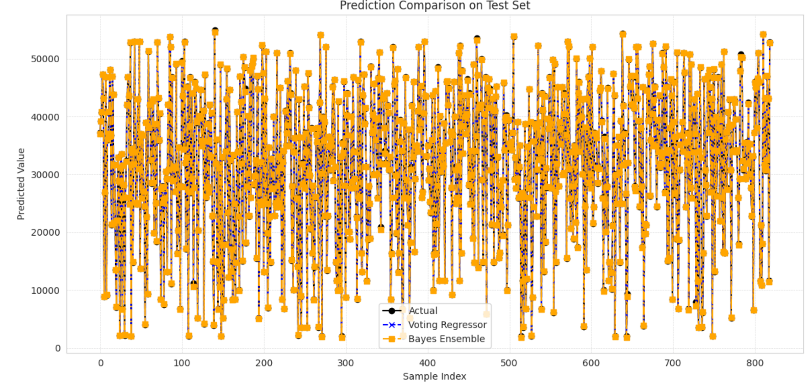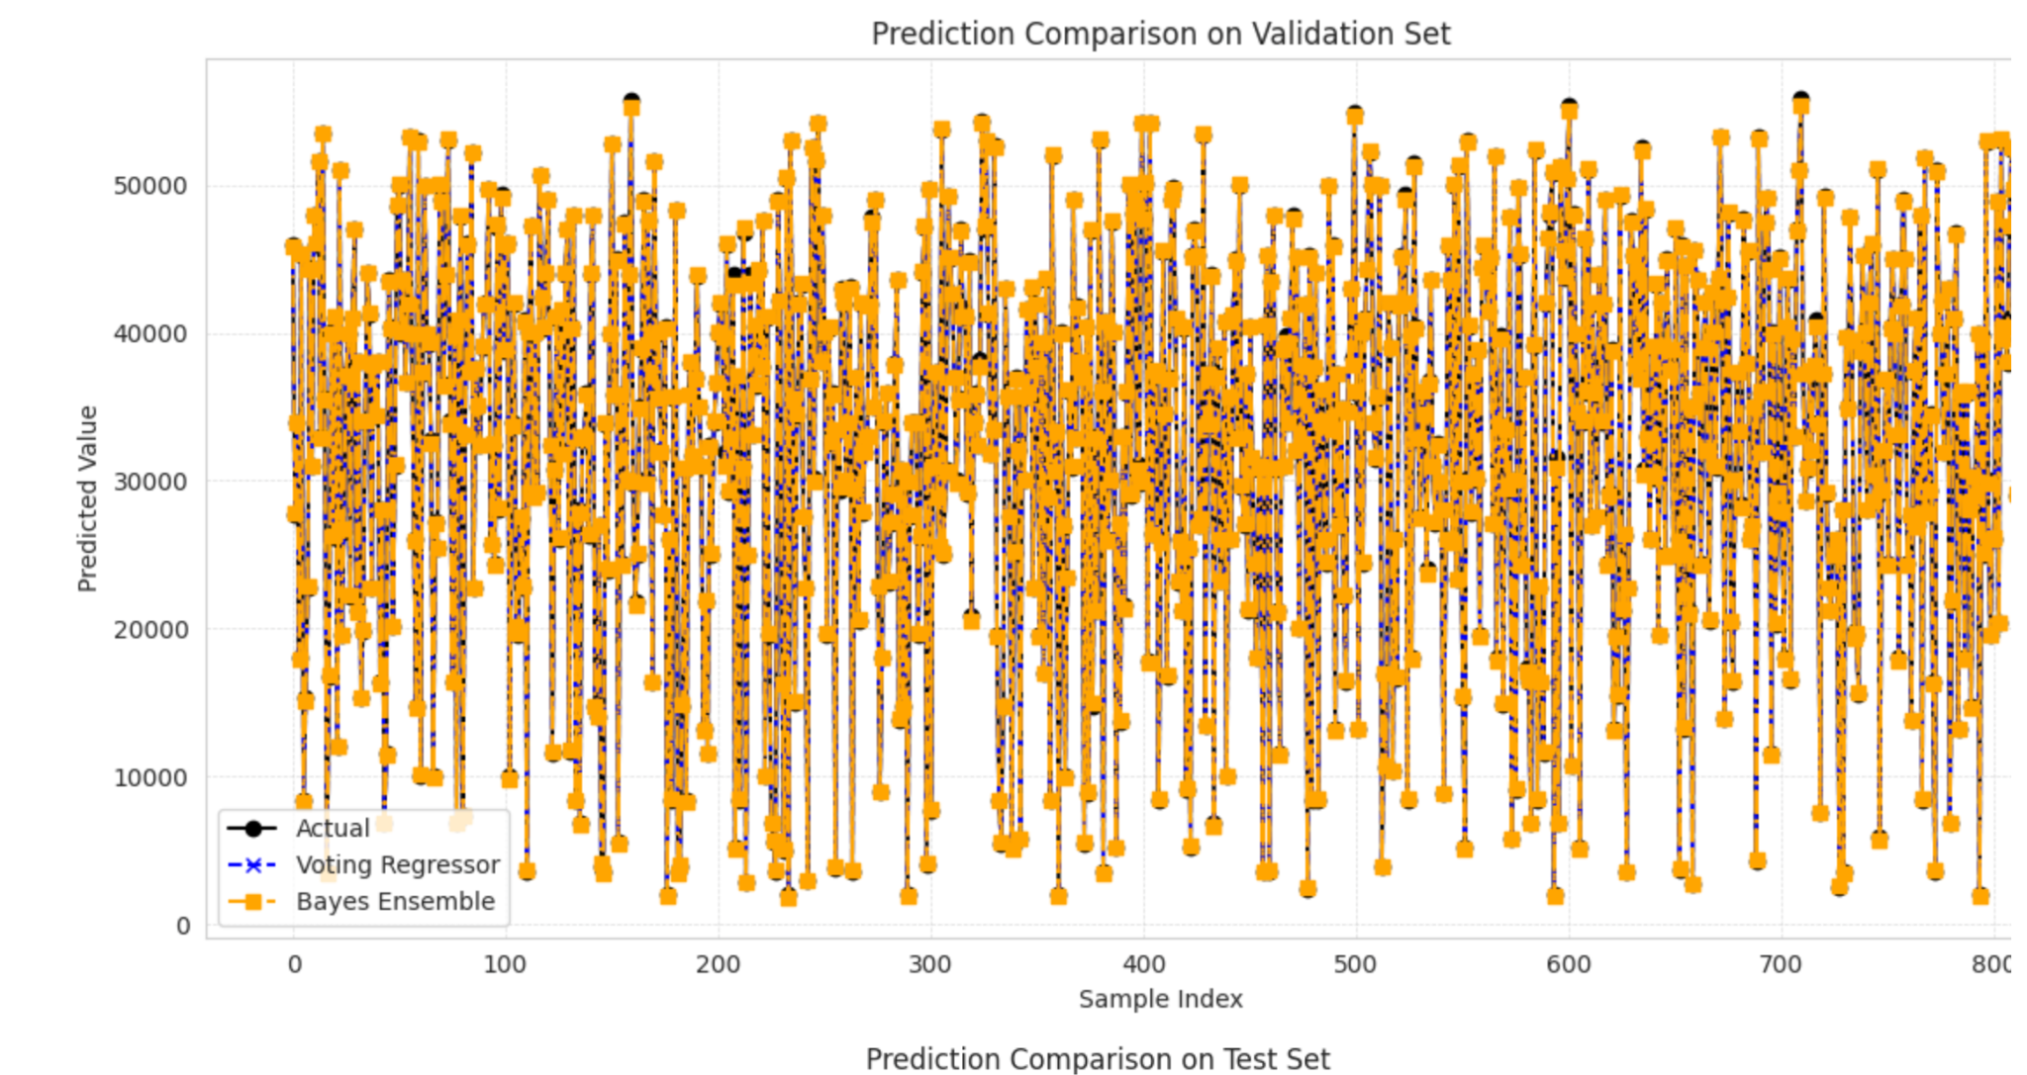

Regression | MAE | MSE | Rsquared
Linear Regression | 219.76 | 73,797.42 | 0.9996
Decision Tree | 56.43 | 30,672.04 | 0.9998
Random Forest | 49.60 | 20,619.94 | 0.9999
XGBoost | 39.47 | 4,879.56 | 1.000
K-Nearest Neighbors | 3,530.60 | 31,139,240.10 | 0.81553
Voting | 3,530.60 | 31,980,994.97 | 0.8153
Bayseian | 79.58 | 12,870.31 | 0.9999

Selection Justification
After evaluating all options, we decided to go with the Bayesian Ensemble as it gives us the most consistent and accurate predictions for car prices. Here is the rationale for it being the best option:
- It takes the best model components – Retrieves predictions from the 3 best models XGBoost, Random Forest, and Linear Regression, picking the most accurate which happens to be XGBoost.
- All-around accuracy - Is able to get prices right within about 80 on average MAE=79.58, which sufficiently meets market needs for car prices.
- More reliable - While XGBoost only got slightly better test scores compared to the rest, the ensemble is better at dealing with outliers, thereby maintaining performance regardless of how volatile the market is.
- Better for business – The model is robust, simple, and performs well on virtually all vehicle types- from standard sedans to exotic luxury cars.
This is the approach we selected because it allows us to balance ultra-precise pricing with dependability that dealerships and buyers can trust on a daily basis.

